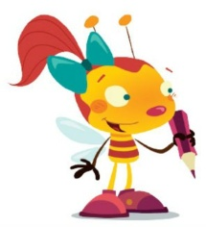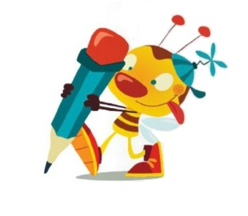

**PIŠEMO**

|  |  |  |  |  |
| --- | --- | --- | --- | --- |
| http://bestclipartblog.com/clipart-pics/scissors-clip-art-5.jpg |  | http://www.clker.com/cliparts/D/j/8/k/V/M/colored-bed-hi.png |  | http://clipartist.info/www/CLIPARTIST.ORG/lemmling/lemmling_simple_cartoon_mouse_1_scalable_vector_graphics_svg-2555px.png |
|  |  |
|  |  |  |
|  |  |  |
|  |  | http://bestclipartblog.com/clipart-pics/ice-cream-clip-art-1.jpg |  | http://static.freepik.com/free-photo/fried-egg-clip-art_422221.jpg |
| http://www.clker.com/cliparts/e/c/2/c/11954410851373638183Gerald_G_Cartoon_Cat_Sitting.svg.med.png |  |  |  |  |
|  |  |
|  |  |  |
|  |  |  |
| http://www.clipartpal.com/_thumbs/pd/weather/sun_kicking_blue.png |  | http://www.clker.com/cliparts/3/1/9/H/d/a/sack-hi.png |  | http://www.clipart-box.com/zoom/cartoon-donkey121101.jpg |
|  |  |  |  |  |
|  |  |
|  |  |  |
|  |  |  |
| http://www.clker.com/cliparts/S/r/B/n/R/A/cartoon-house-md.png |  | http://www.clipartlord.com/wp-content/uploads/2013/12/motorcycle-helmet3.png |  | http://www.clipartbest.com/cliparts/9c4/E5o/9c4E5oBcE.png |
|  |  |  |  |  |
|  |  |
|  |  |  |
|  |  |  |



POČASI! PREVIDNO! NATANČNO!

NE POZABI NAME! MED VSAKO BESEDO STOJIM JAZ!

**PIŠEMO**

SONCE MOČNO SIJE.

|  |
| --- |
|  |
|  |
|  |
|  |
|  |
| SOVA LOVI MIŠI. |
|  |
|  |
|  |
|  |
|  |
| SVEČA SVETI V TEMI. |
|  |
|  |
|  |
|  |
|  |
| SONJA IŠČE MAČKO. |
|  |
|  |
|  |
|  |
|  |
| SOVA JE NA VEJI. |
|  |
|  |
|  |
|  |
|  |